St Thomas CE (VC) Primary School
Additional Funding report
Including
- Pupil premium statement
- Sports premium statement
- Additional needs statement (SEN)
- Looked after children statement
REPORTING DATE: December 2017
How St Thomas CE (VC) Primary School Uses Additional Funding to Further Improve Outcomes for Children

Pupil Premium
Introduction
The pupil premium is additional funding for publicly funded schools in England to raise the attainment of disadvantaged pupils of all abilities and to close the gaps between them and their peers.
Funding - Financial year 2016 to 2017
In the 2016 to 2017 financial year, schools will receive the following funding for each child registered as eligible for free school meals at any point in the last 6 years:
- £1,320 for pupils in reception year to year 6
- £935 for pupils in year 7 to year 11
Schools will also receive £1,900 for each pupil identified in the spring school census as having left local-authority care because of 1 of the following:
- adoption
- a special guardianship order
- a child arrangements order
- a residence order
If a pupil has been registered as eligible for free school meals and has also left local-authority care for any of the reasons above, they will attract the £1,900 rate. Children who have been in local-authority care for 1 day or more also attract £1,900 of pupil premium funding. Funding for these pupils is managed by the virtual school head (VSH) in the local authority that looks after the child.

Funding allocations
In June 2016 we published pupil premium allocations for the 2016 to 2017 financial year based on January 2016 school census data.
Mission Statement
St Thomas CE vc Primary School aims to be a school of opportunity and success for all pupils, including, and especially, those who are in receipt of the Pupil Premium. Our school pupils eligible for the Pupil Premium are identified quickly so that we can support needs effectively.
The needs analysis for the Pupil Premium is an on-going process throughout a pupil’s career at our school. We believe that the measure of successful spending should be raising standards, the narrowing of the achievement gap and the broadening of opportunities for the most disadvantaged pupils at St Thomas’s School.
Our Approach
The school has created a team of staff that work across each cohort to identify and support any child that may not be making progress. This identification process is rooted in our assessment procedure which highlights any individual that may not be working at the level that they are expected to be. This allows the teacher to direct their mentor efficiently and effectively as well as discussing vulnerable children within the regular pupil performance meetings with the leadership team.
Leadership: Head Teacher and assessment coordinator
Class Teacher assesses using daily AFL and class track
EYFS  Learning Mentor  Early identification and support | Year 1  Learning Mentor  Core skills Daily intervention | Year 2  Learning Mentor  Previously identified children at risk. Targeted support with daily consolidation. | Year 3  Learning Mentor  Previously identified children at risk. Targeted support with daily consolidation. | Year 4  Learning Mentor  Previously identified children at risk. Targeted support with daily consolidation. | Year 5  Learning Mentor  Previously identified children at risk. Targeted support with daily consolidation. | Year 6  Learning Mentor  Previously identified children at risk. Targeted support with daily consolidation.
Many of our children belong to one or more potentially vulnerable groups. For example…
Some children may be identified as accessing free school meals, speak English as a second language as well as being involved in safeguarding and child protection issues. This means that we have to assess and track our children very closely, identifying individual need and providing the right support at the right time. The following opportunities offer the chance for the school to help a child to be safe, happy and to learn effectively.

How the funding is used
Analysis | In | Out
Pupil Premium Funding 2017/18 – Current Year Allocation/Budget – 1.9.17 to 31.3.18 only
(7/12 x full year allocation £199206) | 116204
Targeted pupil support – Inclusion Team |  | 102744
Teachers with Early Years/ Reading & Writing leadership responsibilities – TLR2 |  | 4665
Learning at home resources |  | 583
Subsidised trips – costs less contributions |  | 3208
1:1 Tuition |  | 158
Before/ After School Clubs – Library, ICT am, Nessy, Dizzy Stitches |  | 1254
Educational Psychologist, Speech & Language Therapist |  | 7000
Breakfast Club – staffing costs plus provisions less 80p charges |  | 1119
GROW outdoor learning sessions and afterschool club |  | 8750
Part Current Year - 2017/18 Balances | £ 116204 | £ 129481
Total Pupil Premium Funding 2016/17 – Previous Year Allocation/Actual – 1.9.16 to 31.8.17 | 201385
Targeted pupil support – Inclusion Team |  | 196494
Teachers with Early Years/ Reading & Writing leadership responsibilities – TLR2 |  | 5031
Learning at home / assessment resources |  | 457
Intervention /Assertive Mentoring |  | 2144
Subsidised Trips – costs less contributions |  | 8397
1:1 Tuition |  | 234
Before/ After School Clubs – Library, ICT am, Computer, Homework, Nessy, Dizzy Stitches |  | 2149
Educational Psychologist, Speech & Language Therapist |  | 10369
Breakfast Club – staffing costs plus provisions less 50p/80p charges |  | 1693
Full Previous Year - 2016/17 Balances | £ 201385 | £ 226968

Outcomes for our children (2016/17 Data)
EYFS
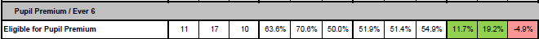

KS1
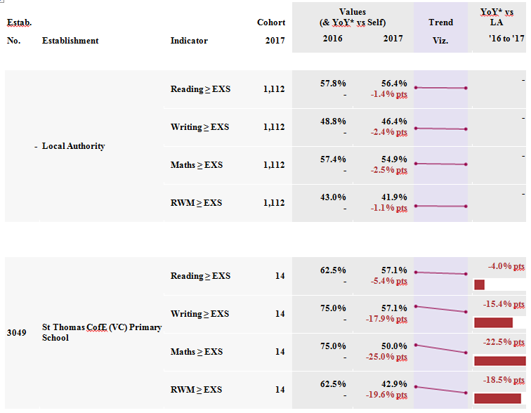
KS2
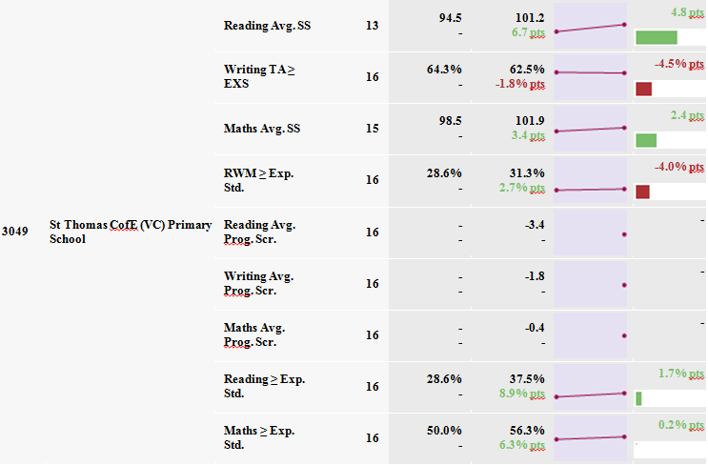

Sports Premium
Introduction
The Government has providing funding of over £450 million per annum for academic years from 2013 – 2016 to provide new, substantial primary school sport funding’. This funding has now been agreed until 2019. This funding is being jointly provided by the Departments for Education, Health and Culture, Media and Sport, and will see money going directly to primary school headteachers to spend on improving the quality of sport and PE for all their children.
The sport funding can only be spent on sport and PE provision in schools.
Purpose of funding
Schools will have to spend the sport funding on improving their provision of PE and sport, but they will have the freedom to choose how they do this.
Possible uses for the funding include:
- hiring specialist PE teachers or qualified sports coaches to work alongside Primary teachers when teaching PE
- new or additional Change4Life sport clubs
- paying for professional development opportunities in
- PE/sport
- providing cover to release primary teachers for professional development in PE/sport
- running sport competitions, or increasing participation in the school games
- buying quality assured professional development modules or materials for PE/sport
- providing places for pupils on after school sport clubs and holiday clubs.
Mission Statement
At St Thomas, we believe that the money must be used so that: all children benefit regardless of sporting ability; that the most able children are given the opportunity to compete in advanced tournaments and that staff have access to training opportunities and continued professional development. Schools receive Sports Premium budget for the financial year, this report is based upon academic years.
Our Approach
For all children, sport is important. We think that our children should grow up enjoying physical activity and experiencing personal success. We also want to see that out children are able to adopt a healthy lifestyle - one where they can discover their talents and have a life-long love of sport. We support each element with the sports premium funding. To do this we take great consideration in making sure that our provision makes the school day special and that the children have chances to participate in their houses, teams, after-school clubs and also through our focused curriculum. Within our curriculum, we have taken two critical aspects of development and created a programme of study that runs throughout each year group. These key themes include tennis, rugby, orienteering and swimming. You can read more about why we created these themes below. We also have a wide range of additional opportunities through our partnership work.
Striking and field – Tennis
This academic year has seen the inception of the St Thomas Tennis Academy. Tennis can be a difficult sport to access for many children and yet we think that it is the best way to develop some core skills. Tennis is a striking and fielding game and it helps to develop individual coordination, as each player is constantly involve in play.
The idea behind the academy is that every child from the age of 5 until they leave the school will have access to Tennis lessons, competitions, and visits to Tennis events. The first year has been a resounding success. Every child in the school has received Tennis Lessons from LTA qualified coach Andy Smith and had the option to attend an after school tennis club.In addition to this 6 children from each year group have been selected to attend extra lessons and competitions at Rastrick Tennis club, where some have now become members. Furthermore in June a fantastic opportunity has arisen for the school to take thirty children to Ilkley Tennis club to have tennis lessons on grass courts, followed by watching part of the Aegon Ilkley Trophy, a precursor to Wimbledon, which will include some of Britain’s victorious Davis Cup side.
Orienteering – The Three Peaks Challenge
The St Thomas Three Peaks Challenge gives every child in the school the opportunity to climb the Yorkshire Dales Three Peaks. We have our own fully qualified Mountain Leader in school to lead each expedition. Children taking part do so by choice and on a Saturday.The Three Peaks are Pen-y-Ghent, Ingleborough and Whernside. They are all 600 metres above sea level, situated in the Yorkshire Dales National Park and well known.
Climbing the Three Peaks is a serious and unusual challenge for primary school aged children. Each child has to be properly equipped with boots, waterproofs, warm clothing, high energy food and a rucksack.From Bradley it is just possible for us to climb one peak as a day trip. We climb a peak each year in order of height and present a medal for each peak climbed.
Invasion games – Rugby
The St Thomas Rugby Academy is an initiative set up to introduce the concept of Rugby. As in years gone by, Rugby was a sport taught at Secondary school and even now is still only taught at certain high schools. In addition to this, most schools will focus solely on teaching the specifics of Rugby Union or Rugby League. At St Thomas, we believe that it’s the fundamentals from both codes which are important, giving of all pupils the opportunity at KS2 to participate in a sport which promotes a number of skills in addition to teamwork, fitness and fun. This are of the curriculum is considered to be an 'invasion game', which is a key part of learning to work within a team. Thanks to a high level of quality coaching, staff from St Thomas and the Huddersfield Giants work hard to deliver a programme (based on Tag Rugby) which gives our pupils a taste for more and an enjoyable experience they’ll never forget. With lots of freedom, no restrictions or complications, the St Thomas Rugby Academy is a great place to introduce Rugby.
"It’s great fun and you learn new things every week, I really enjoy myself - it’s 10/10." Eva - Y6.
“ I think it’s a really good club, we gain experience and it brings people together." Callum Y5.
"It is awesome and cool. I really like Rugby.” Kiera Y4.
“It was fun and I enjoyed it. I liked playing against other teams in the St Thomas Rugby festival. Learning to play Rugby means I can play against my Dad.” Ellis Y3.
Swimming
We have a record to be proud of at St Thomas. Over the last six years, 100% of the children have learned to swim. The objective is to make sure that every child can swim 100 metres. To do this our children swim from year 3 through to year 5, with some additional sessions where required. We also make sure that those children who have a particular skill in this area, have an opportunity to represent the school in our annual swimming gala.

How the funding is used
Analysis | In | Out
Funding 2017/18 – Current Year Allocation/Budget – 1.9.17 to 31.3.18 only | 11340
Pennine Sports Partnership subscription |  | 1246
Curriculum & Talent ID Tennis programme – afternoon and after school sessions |  | 2340
Sports clubs – basketball, netball, football run by Inclusion Team – see Pupil Premium |  | -
Football Coaching & Equipment, Duathlon Training, Bikeability |  | 1060
BMX Track development – quoted cost |  | 10500
Part Current Year - 2017/18 Balances | £ 11340 | £ 15146
Total Funding 2016/17 – Previous Year Allocation/Budget – 1.9.16 to 31.8.17 | 9665
Pennine Sports Partnership + G&T programme |  | 1968
Curriculum & Talent ID Tennis programme |  | 3214
School staffed sports clubs - netball, basketball, football, fitness, hockey |  | 804
Three Peaks Challenges |  | 240
Dance & Parkour sessions |  | 1650
Football equipment |  | 188
Full Previous Year - 2016/17 Balances | £ 9665 | £ 8064

Additional Needs
Introduction
St Thomas CE vc Primary School is an inclusive school where everyone is made to feel welcome. Our school sets out to ensure that all students enjoy high quality learning experiences through which they are able to achieve their full potential. Our inclusive ethos aims to encourage all pupils to be actively involved in their own learning. This involves valuing all pupils and staff equally and reducing barriers to learning and participation.
Mission Statement
At St Thomas we have a vibrant and diverse school community which we celebrate each day. Our school culture is rooted around understanding and mutual respect for each other. This means that we welcome and support each child, ensuring that they can feel happy and safe in school before succeeding with every opportunity. This allows all of our children to grow together with empathy, understanding and compassion. Children who require additional support are carefully considered, with each stage of their education supported.
Our Approach
Staff members seek to identify the needs of pupils with SEN as early as possible. This is most effectively done by gathering information from parents, education, health and care services (and feeding schools or early years settings) prior to the child’s entry into the school. Where needs have not been previously identified staff have an obligation to report observations to the SENCo.
Monitor the progress of all pupils in order to aid the identification of pupils with SEN. Continuous monitoring of those pupils with SEN by their teachers will help to ensure that they are able to reach their full potential.
Make appropriate provision to overcome all barriers to learning and ensure pupils with SEN have full access to the National Curriculum. This will be co-ordinated by the [SENCo and Head Teacher] and will be carefully monitored and regularly reviewed in order to ensure that individual targets are being met and all pupils’ needs are catered for. To ensure that children with special educational needs can access all learning and achieve, we have created a team of support staff who are able to work with expertise and flexibility. This team lessens the reliance on external funding streams, ensuring that each child can receive the right support at the right time.
Work with parents to gain a better understanding of their child, and involve them in all stages of their child’s education. This includes supporting them in terms of understanding SEN procedures and practices and providing regular feedback on their child’s progress.
Work with and in support of outside agencies when the pupils’ needs cannot be met by the school alone. St Thomas receives further support from a wide range of external partners.
Create a school environment where pupils can contribute to their own learning by offering all students the opportunity to voice their own opinions. This is achieved by encouraging positive relationships with adults in school and carefully monitoring the progress of all pupils at regular intervals. Pupil participation is promoted across the school within the security of each vertical tutor group. The tutor community helps to build a sense of belonging, respect and value. A sense of comradeship and team spirit is also encouraged through wider opportunities for participation in school life (e.g. membership of the School Council, affiliation with sports teams and other clubs).

How the funding is used
Analysis | In | Out
Total Funding 2016/17 – Previous Year Allocation/Actual - 1.9.16 to 31.8.17
High Needs Top Up funding | 16382
First £6000 per pupil funded from school block budget x 7 pupils | 42000
Additional Needs support team – 7 staff |  | 89104
SEN resources |  | 781
Before/ After School club – Gross Motor Skills/ Movement |  | 517
2016/17 Balances | £ 58382 | £ 90402

