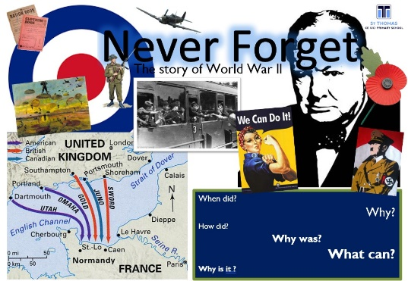
Dear Parents, Carers and year 3 children
We’d like to welcome you back to school after half term.
This half- term our Year 3/4 topic is: This is Never Forget
This topic explores what it was like during World War II and the impact it had on children their own age. We will discuss big questions like ‘Why did it happen?’ We will also look at which countries were involved
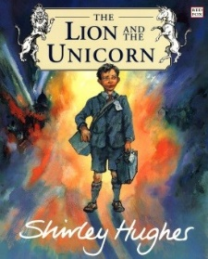
As part of our English we will be:

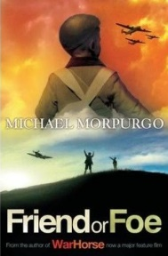
For English we will be following the book ‘The Lion and The Unicorn’ by Shirley Hughes. We will be working on diary entries exploring the experiences and feelings of the main character. For our Reading, our class book will be ‘Friend or Foe’ by Michael Morpurgo. Children will continue to explore word meanings and vocabulary as well as developing their reading fluency.

In Maths we will continue calculating money amounts and then move onto measuring length and perimeter.

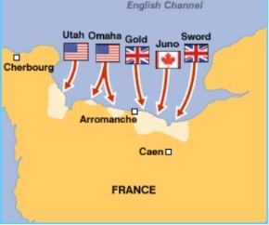
In Science we will learn all about ‘Plants’ where children will compare the effect of different factors on plant growth, such as, the amount of light, the amount of fertiliser; discovering how seeds are formed by observing the different stages of plant life cycles over a period of time; looking for patterns in the structure of fruits that relate to how the seeds are dispersed.
In Geography children will locate countries involved in WWII and explore the land use of the forces during that time.

This half-term Year 3 will also be learning athletic skills in PE. We will be doing PE on a Thursdays so your child needs to come in in their kit on that day.
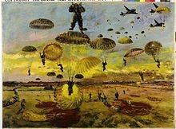
We have already done lots of activities about our health and hygiene! We will be exploring how to look after our teeth in SRE this half term as well as looking at aspects of our theme word ‘Love’. In RE our big question is ‘Why do bad things happen? Our unit is ‘How are important events remembered?’. We will link these questions to the topic of WWII.
We will use Art and Design techniques with pencils and paint to explore and imitate the work of artist Albert Richards.
Please feel free to have a quick chat on the playground and say hello to us. We are happy to answer any queries you may have about school and children’s learning.
All the best,
Miss Dickson and Mrs Sloan

